**MySQL**

DATABASE is a collection of data stored in a format that can easily be accessed

In order to manage the database we use DBMS software

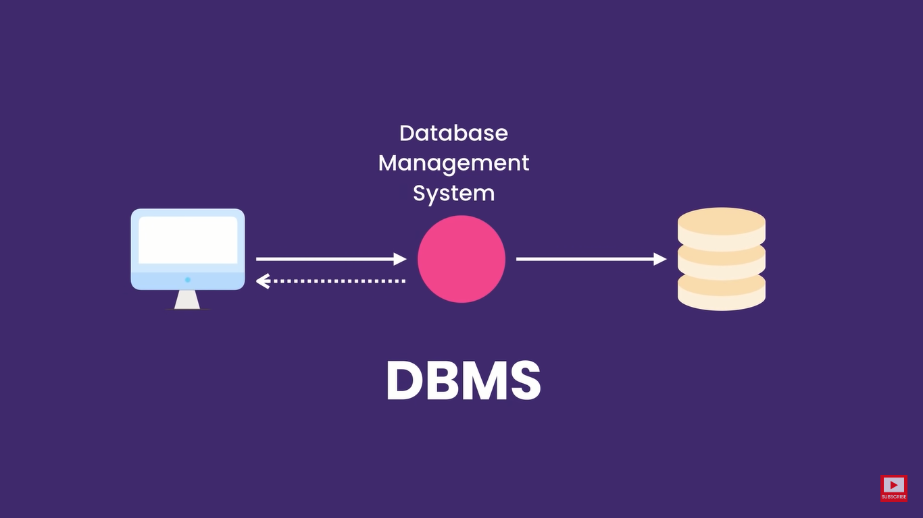

2 types of DATABASE

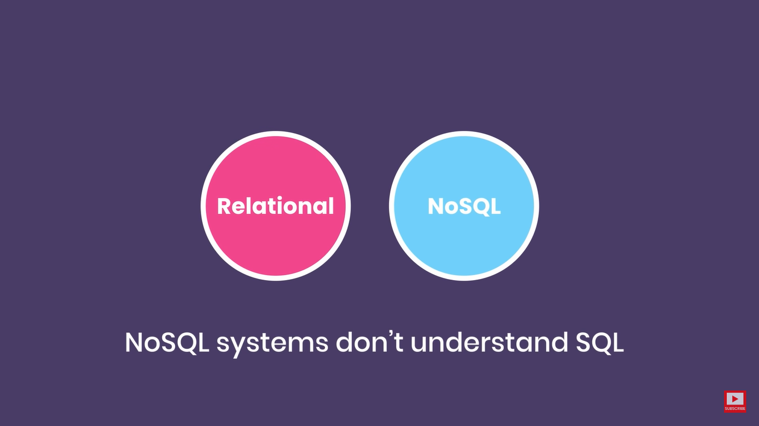

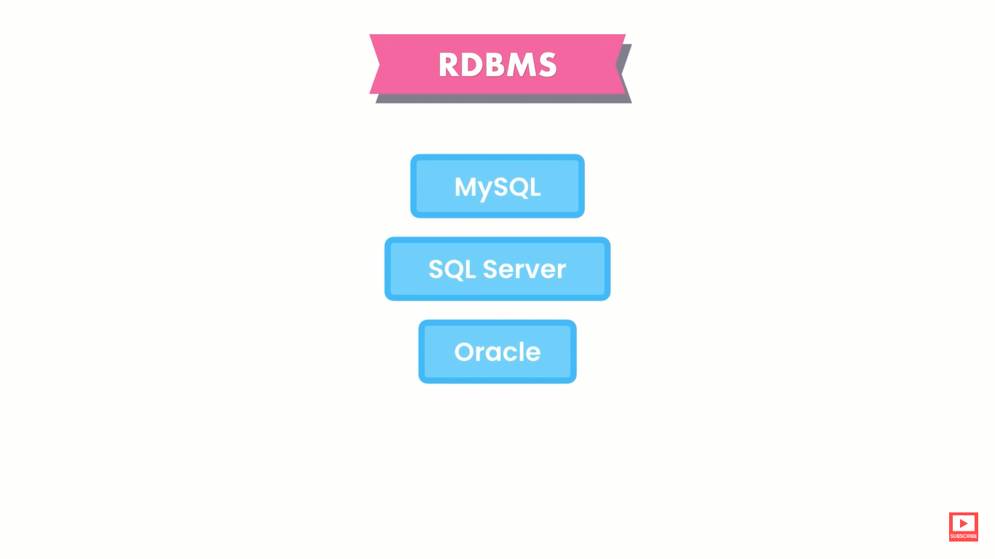

use sql_store ;

SELECT name, unit_price , (unit_price * 1.1) as "new price"

from products;

select *

from orders

where order_date >= '2018-01-01';

use sql_store;

select *

from order_items

where order_id = 6 and ( quantity * unit_price ) > 30;

use sql_store;

select *

from products

where quantity_in_stock in (49 , 38 , 72)

use sql_store;

select *

from customers

where birth_date between '1990-02-01' and '2000-01-01'

use sql_store;

select *

from customers

where address like '%trail%' or address like '%avenue%'

use sql_store;

select *

from customers

where phone like '%9

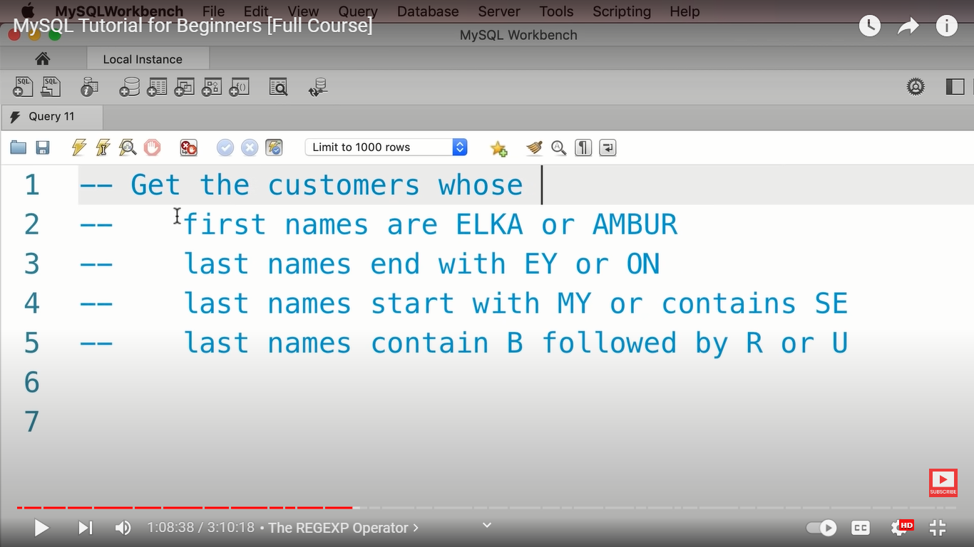

use sql_store;

select *

from customers where first_name REGEXP 'elka|ambur'

use sql_store;

select *

from customers where last_name REGEXP 'ey$|on$'

use sql_store;

select *

from customers where last_name REGEXP '^MY|SE'

use sql_store;

select * from customers where last_name REGEXP 'B[ru]'

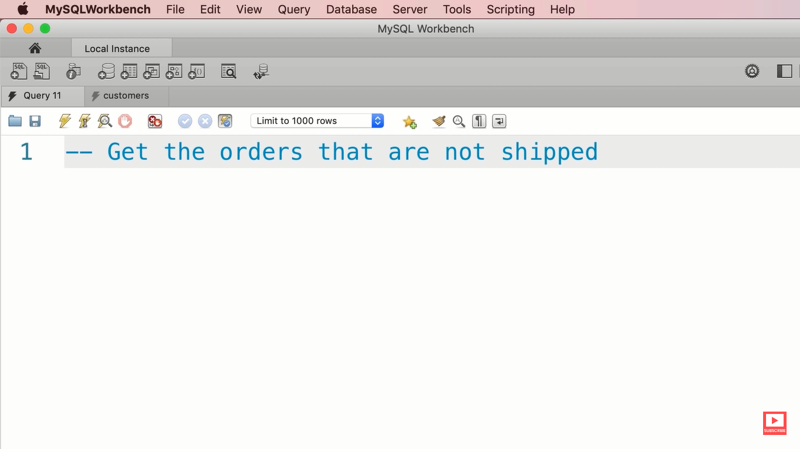

use sql_store;

select *

from orders

where shipped_date is null

use sql_store;

select *

from order_items

where order_id = 2

ORDER BY quantity * unit_price DESC

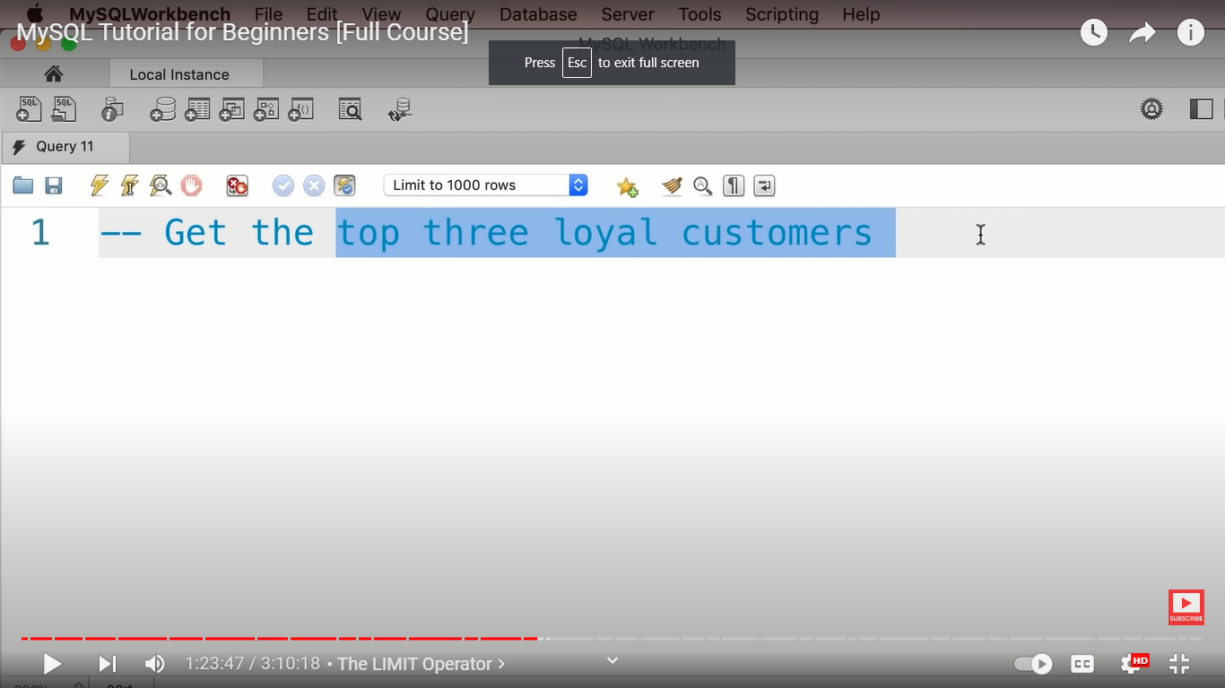

USE sql_store;

SELECT *

FROM customers

ORDER BY points DESC

LIMIT 3

**Joins**

**Inner joins :--**

Return product id and its name and quantity and unit price

USE sql_store;

SELECT products.product_id , name, quantity, products.unit_price,quantity_in_stock,order_items.unit_price

FROM order_items

JOIN products

on order_items.product_id = products.product_id

**Joining Across Databases :---**

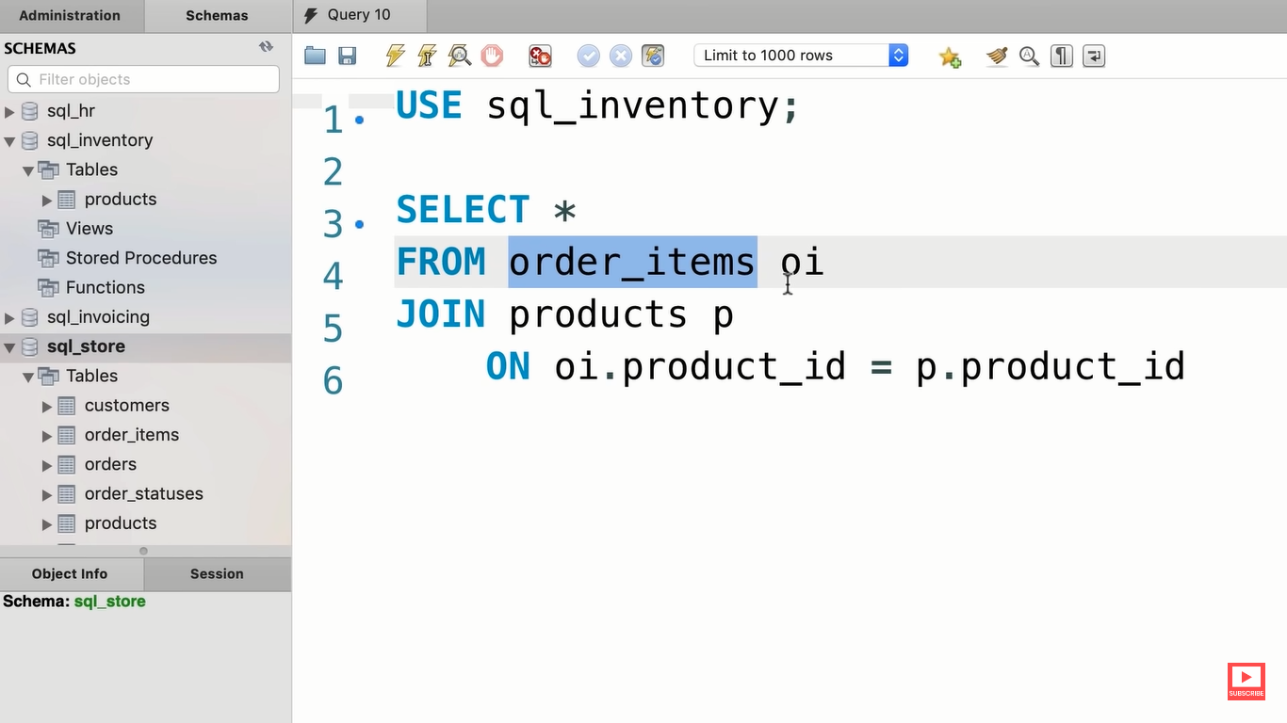

**Self joins :---**

A table can be joined with itself

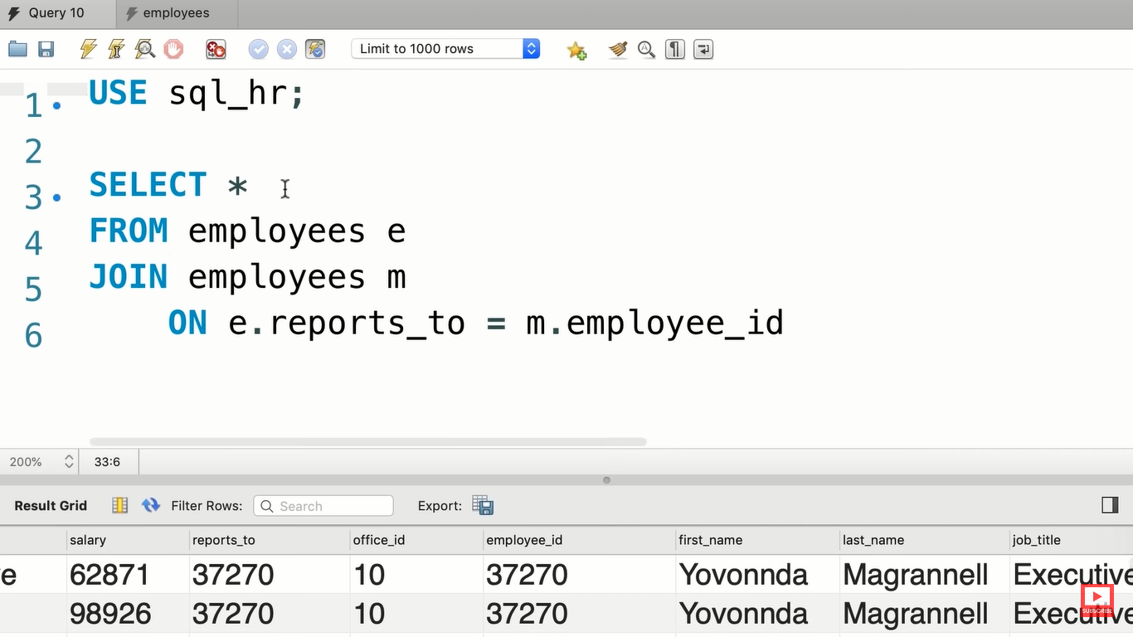

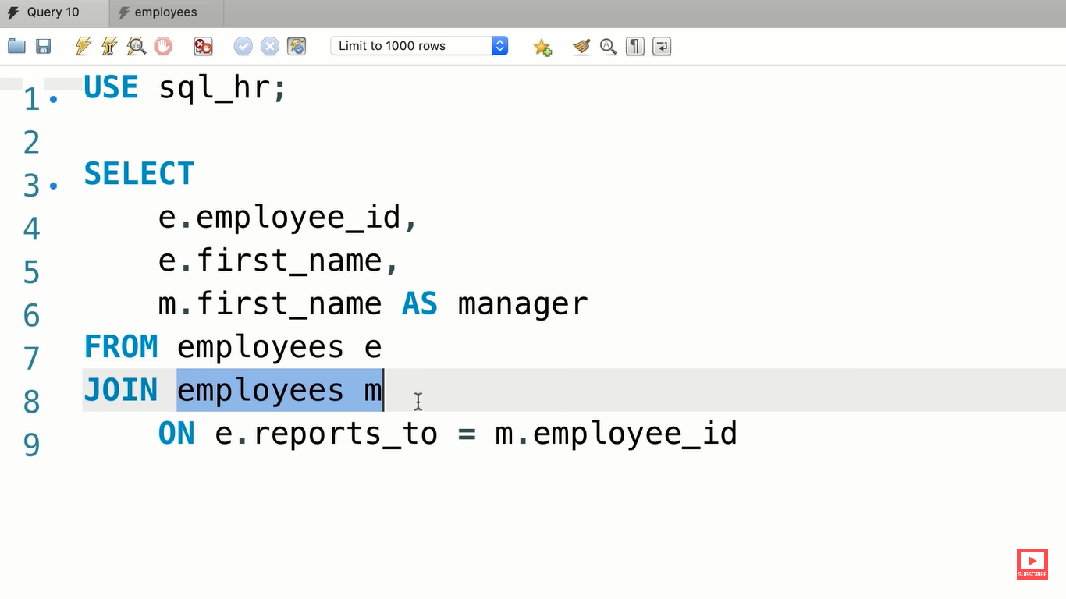

**Joining multiple tables :---**

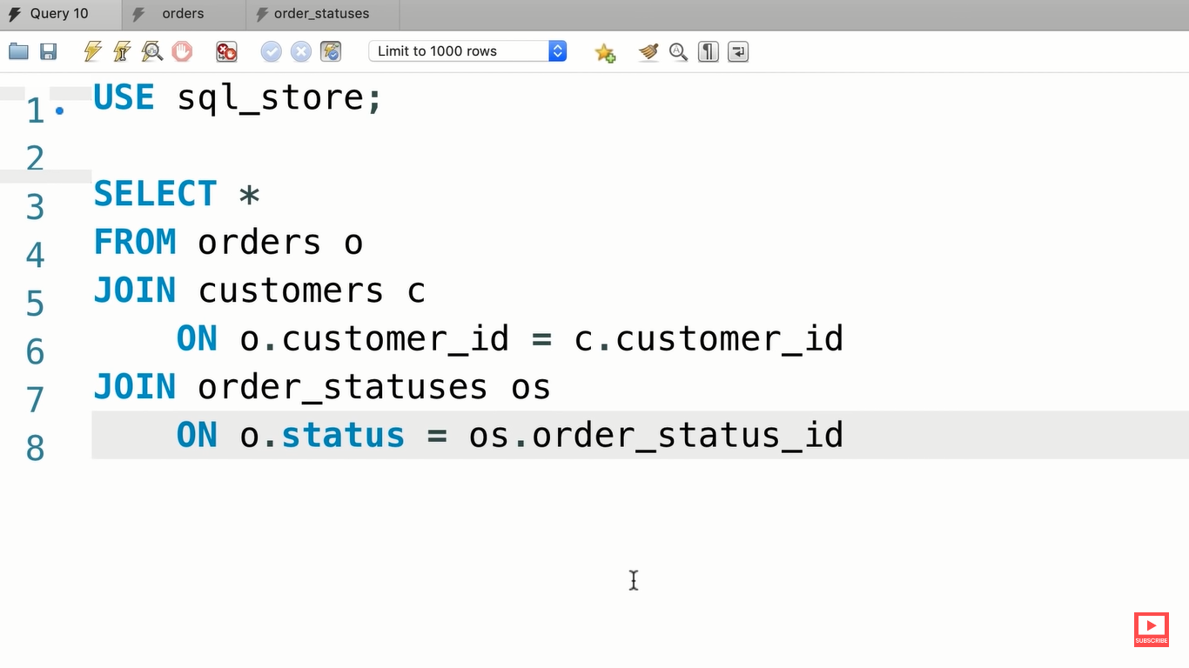

**Compound joining conditions :---**

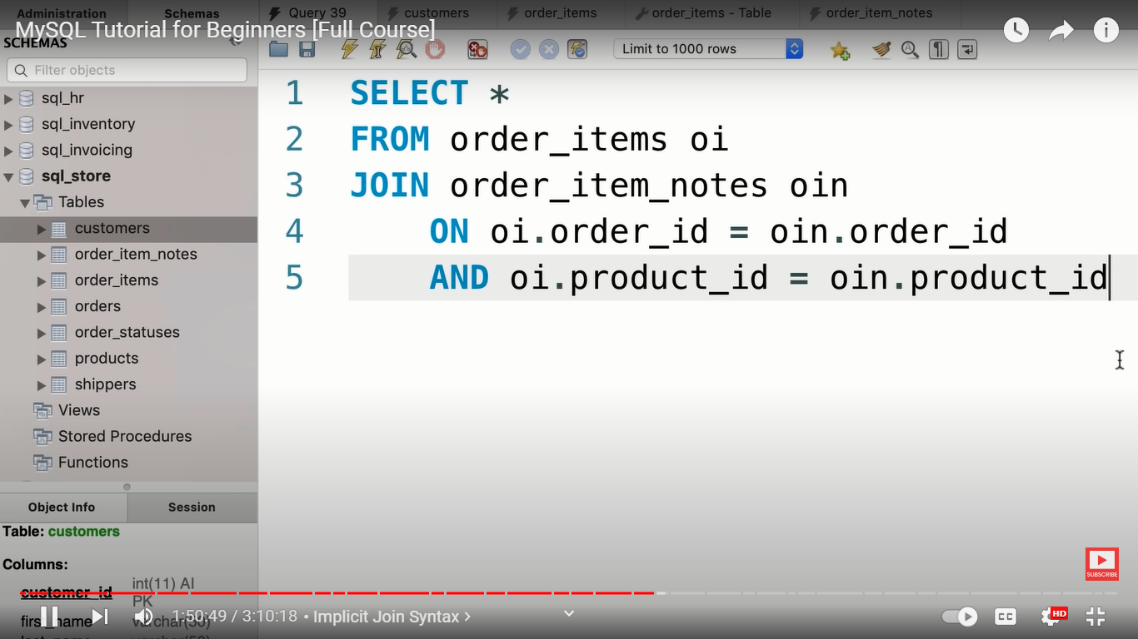

**Implicit join syntax :---**

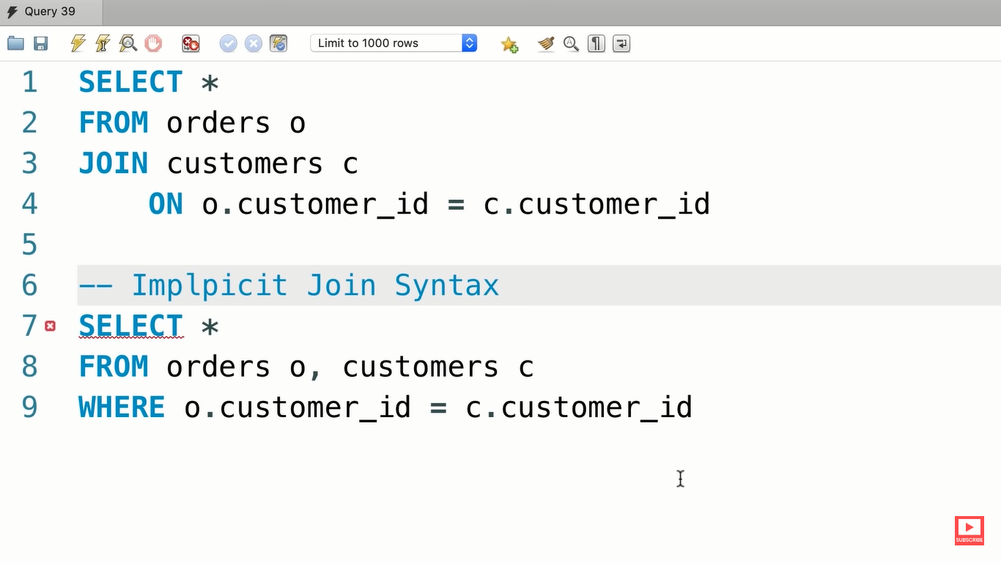

**Outer joins :---**

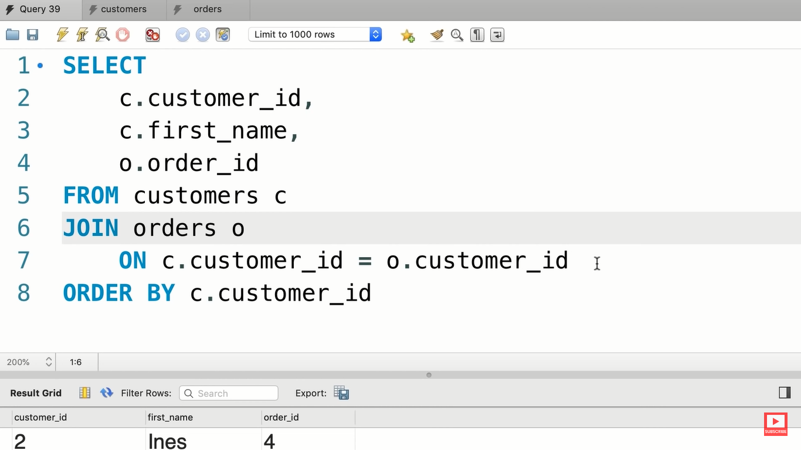

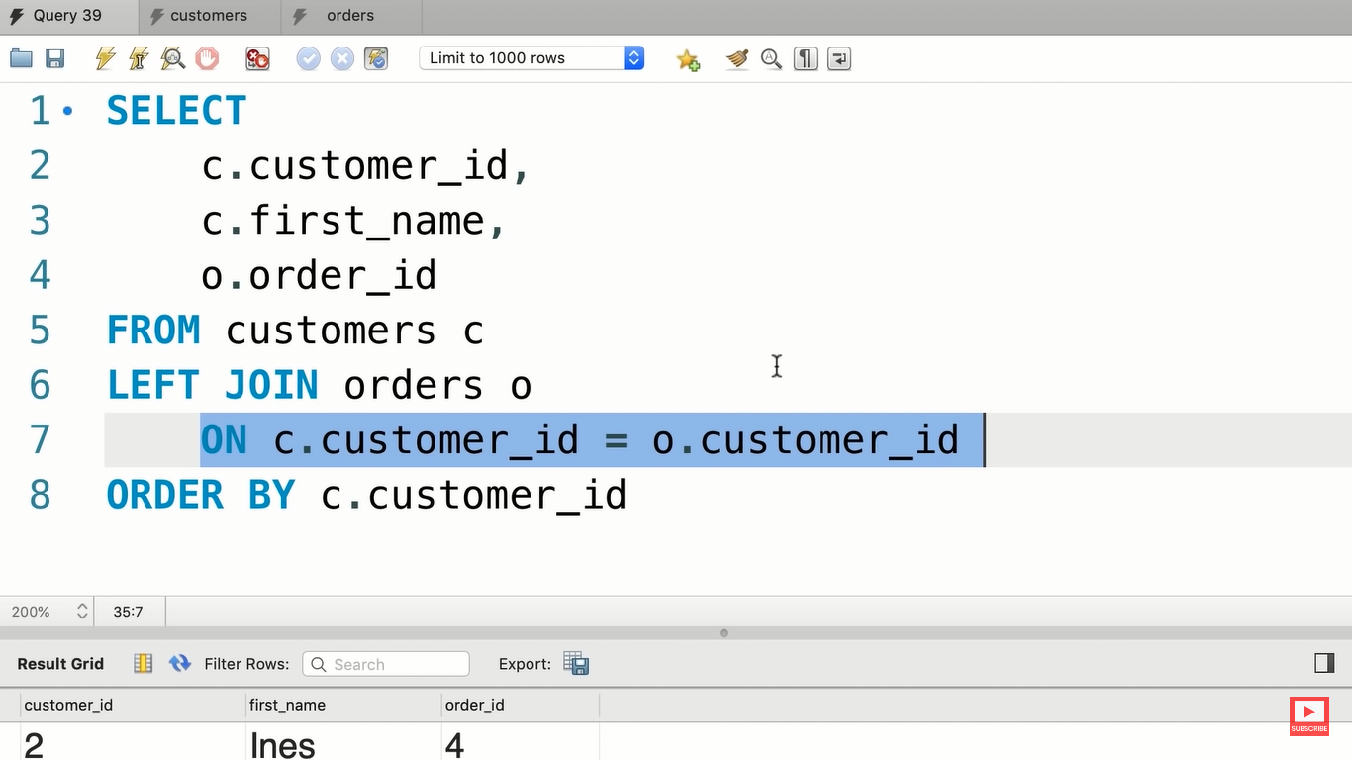

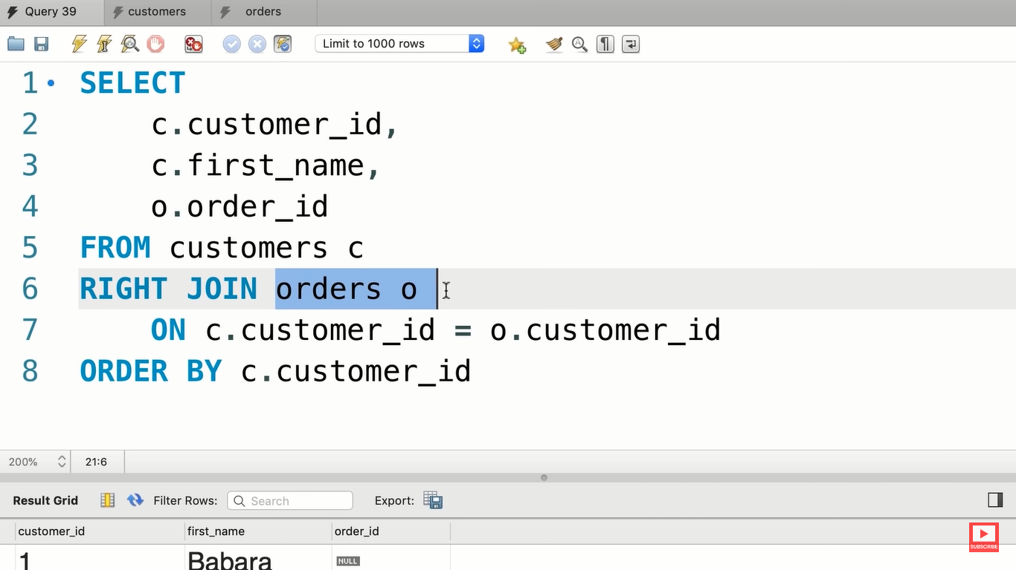

Order items table

Join products table from order items table

USE sql_store;

SELECT p.product_id,p.name,o.quantity

FROM products p

LEFT JOIN order_items o

ON p.product_id = o.product_id

ORDER BY p.product_id

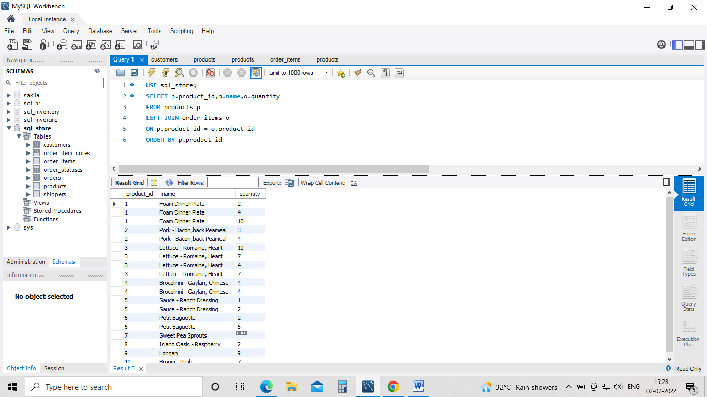

**Outer joins between multiple tables :---**

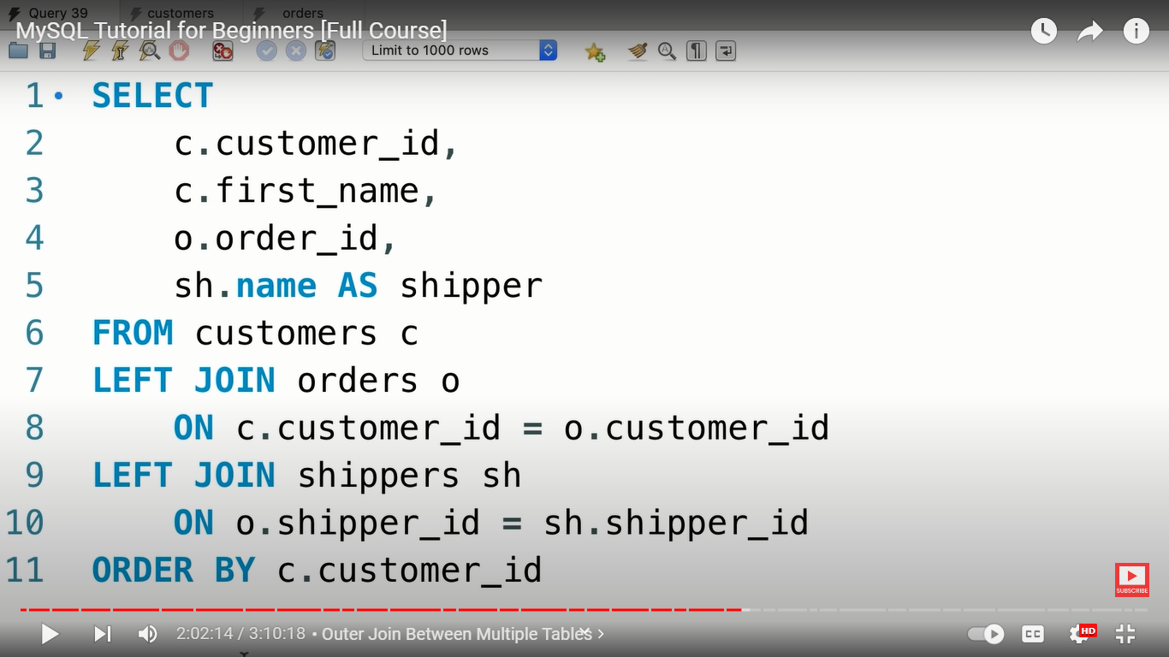

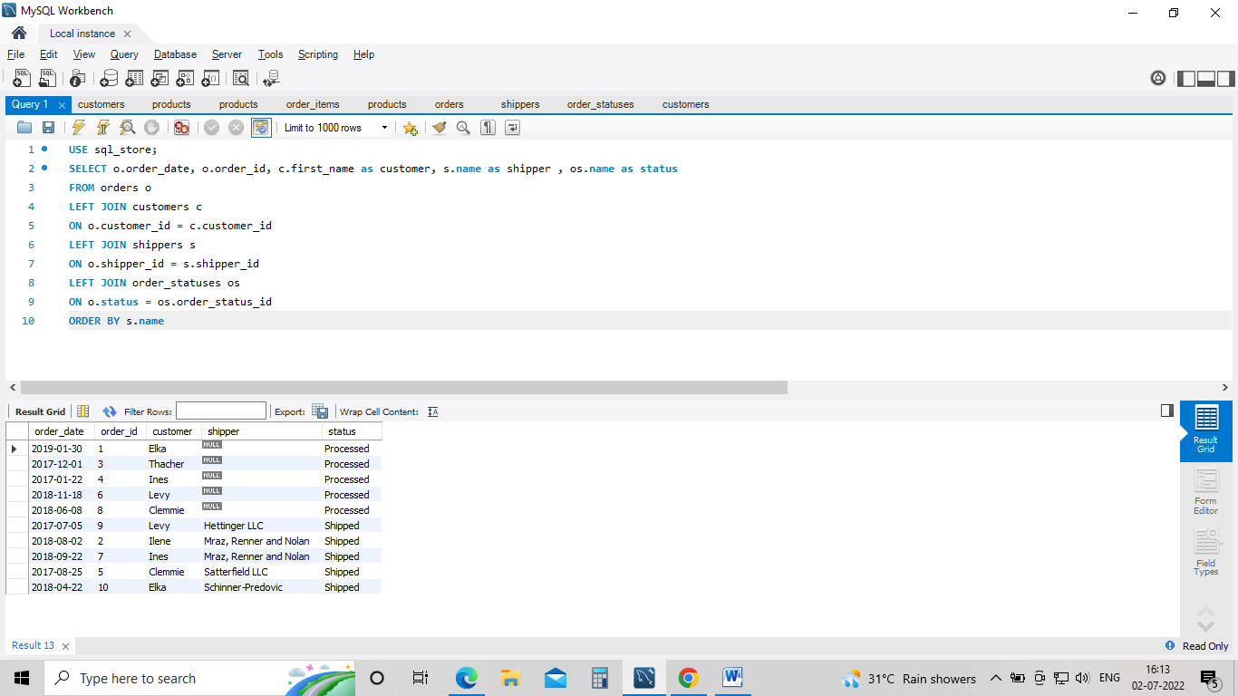

**Self outer joins :---**

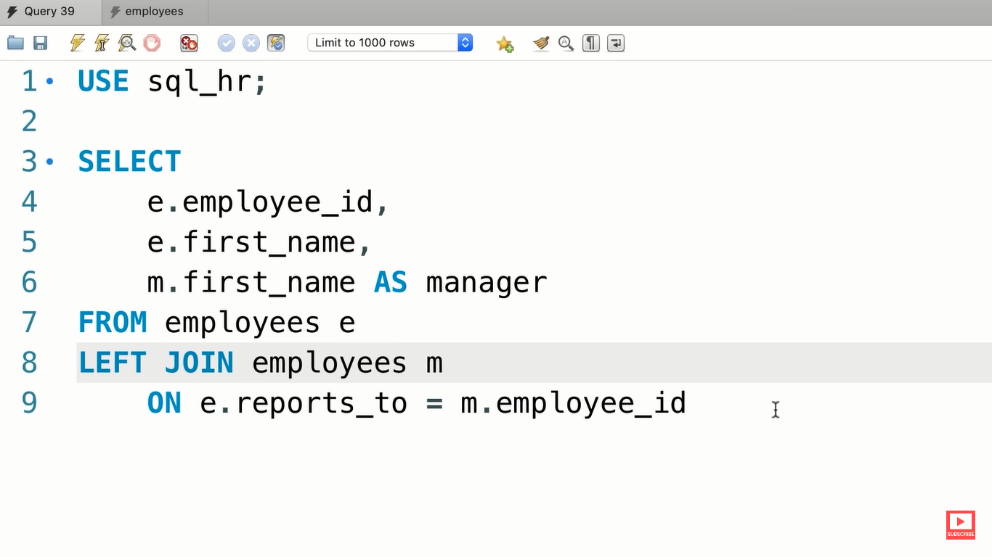

**The USING Clause :---**

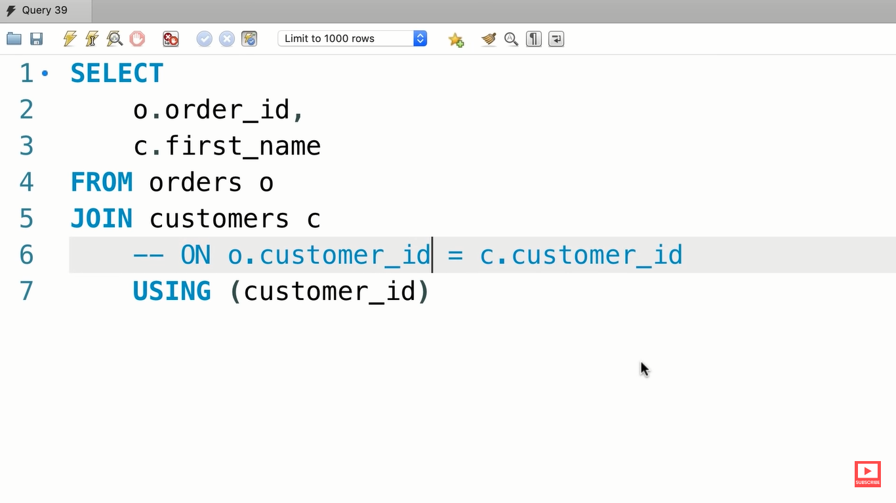

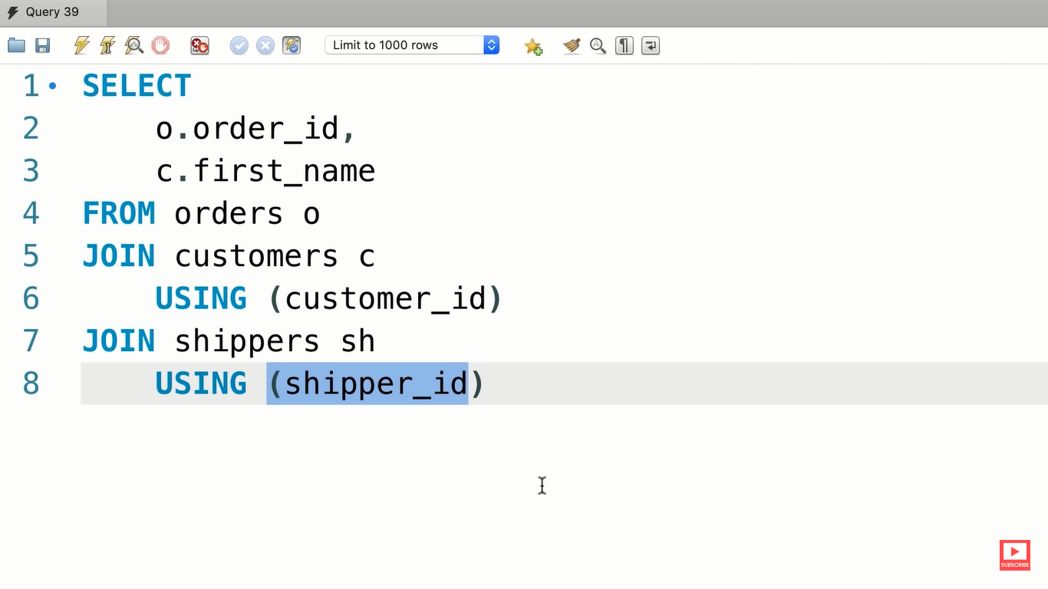

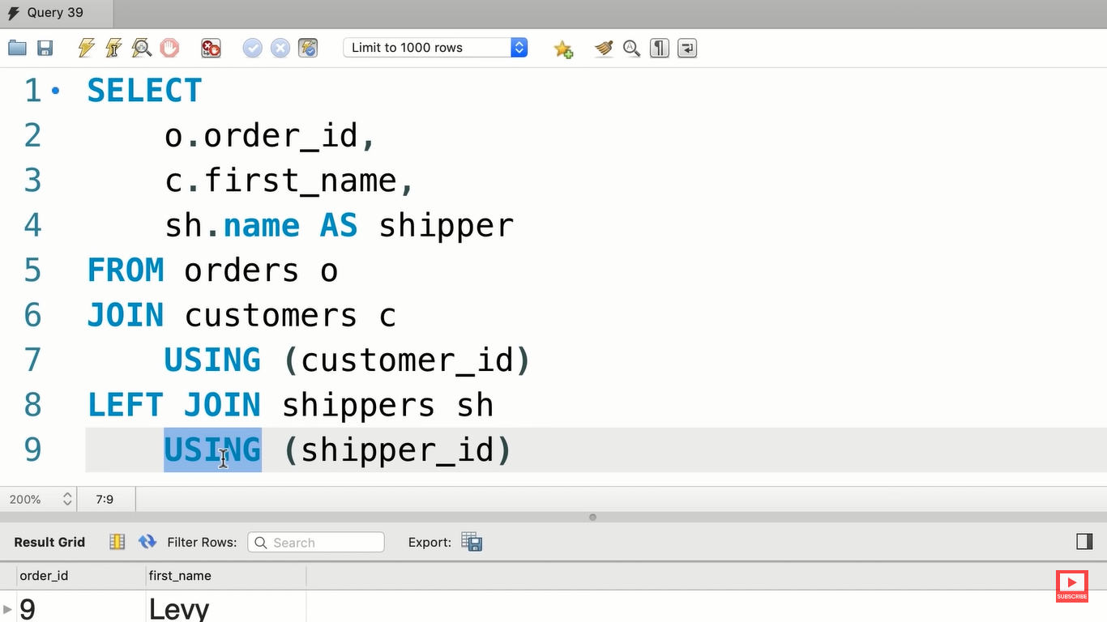

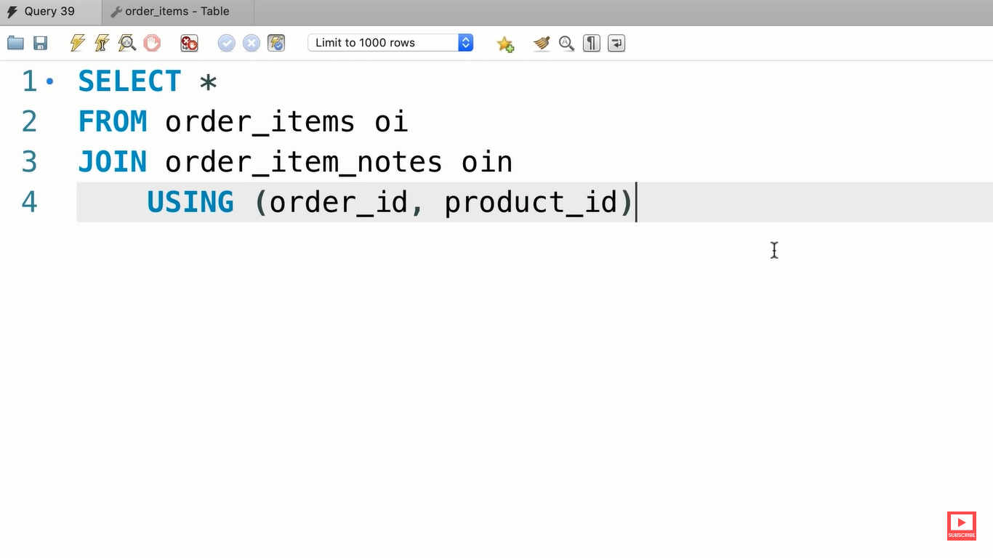

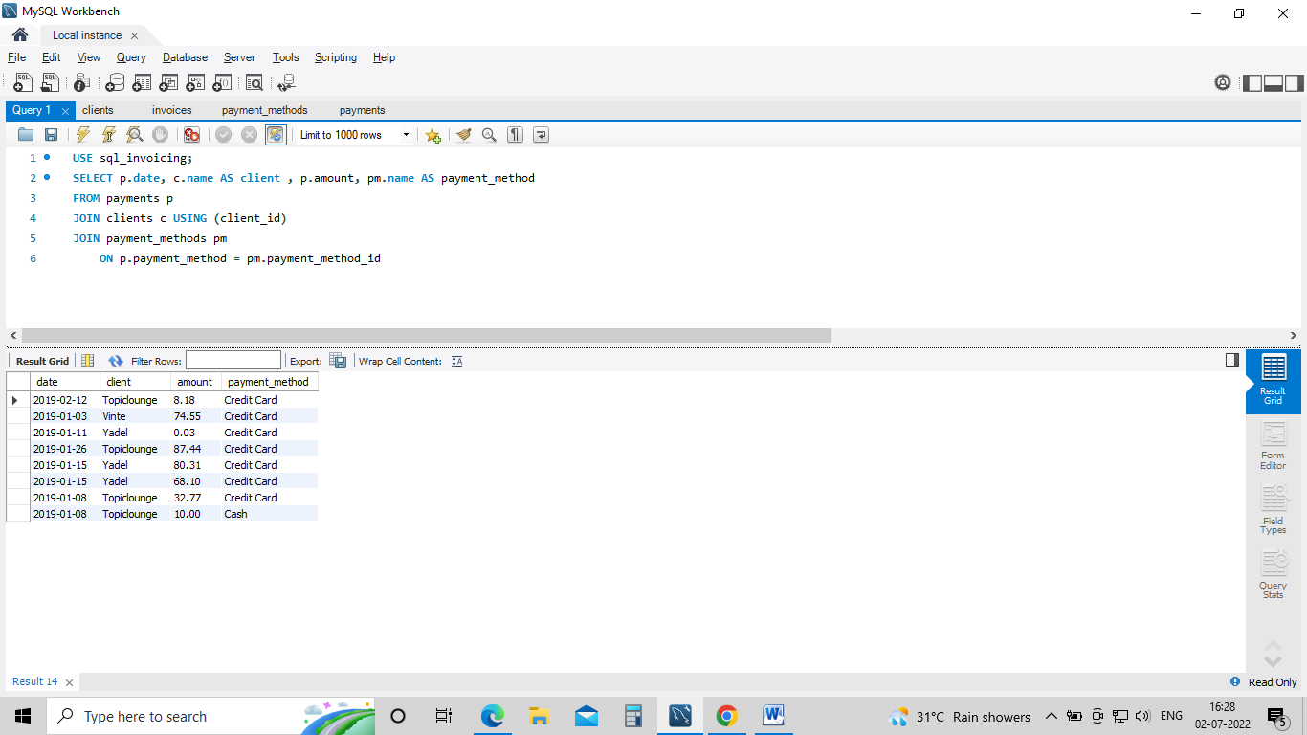

**Cross Joins :---**

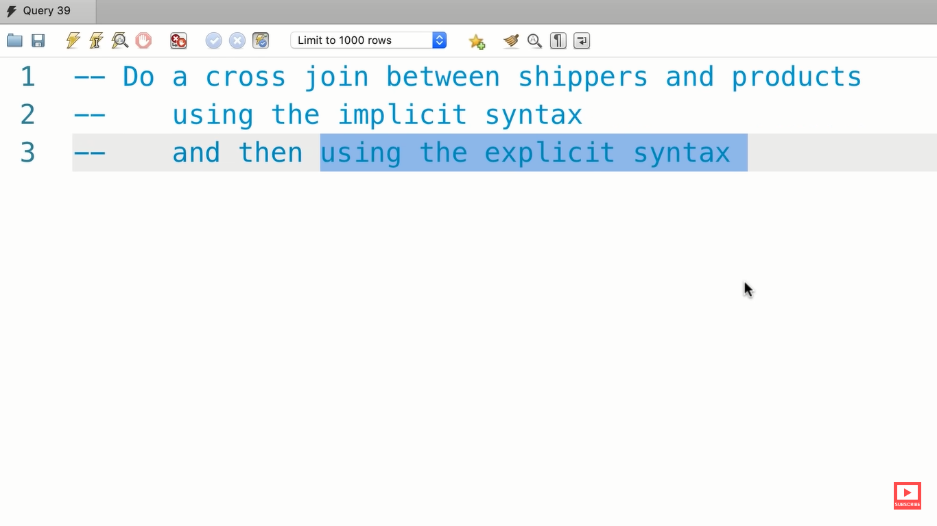

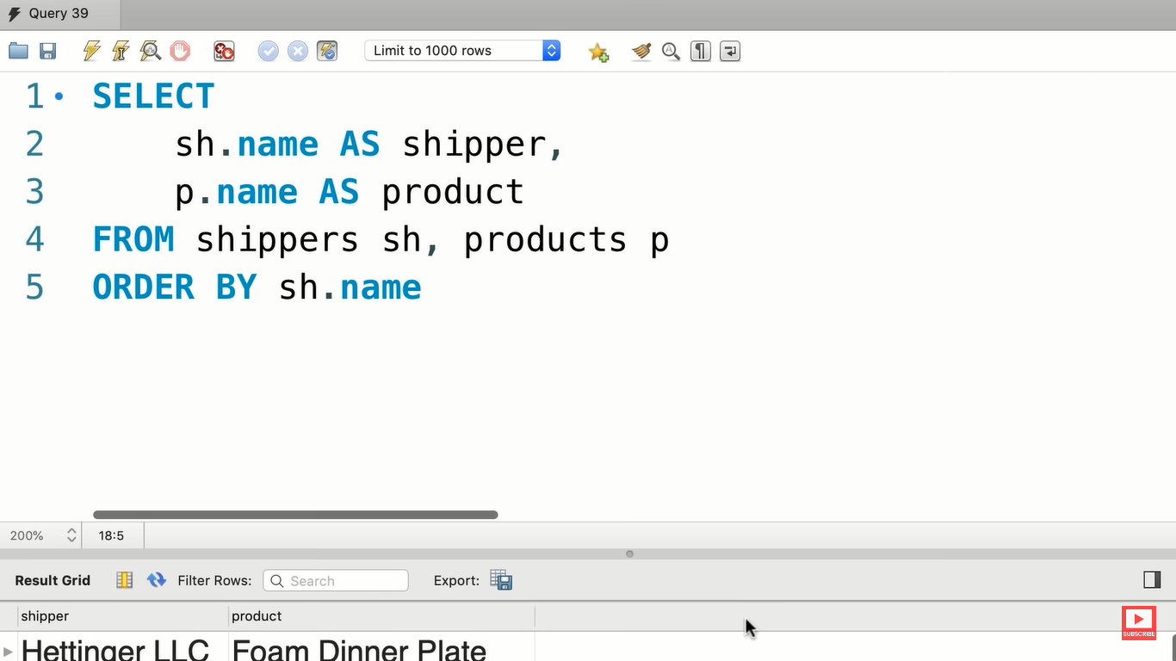

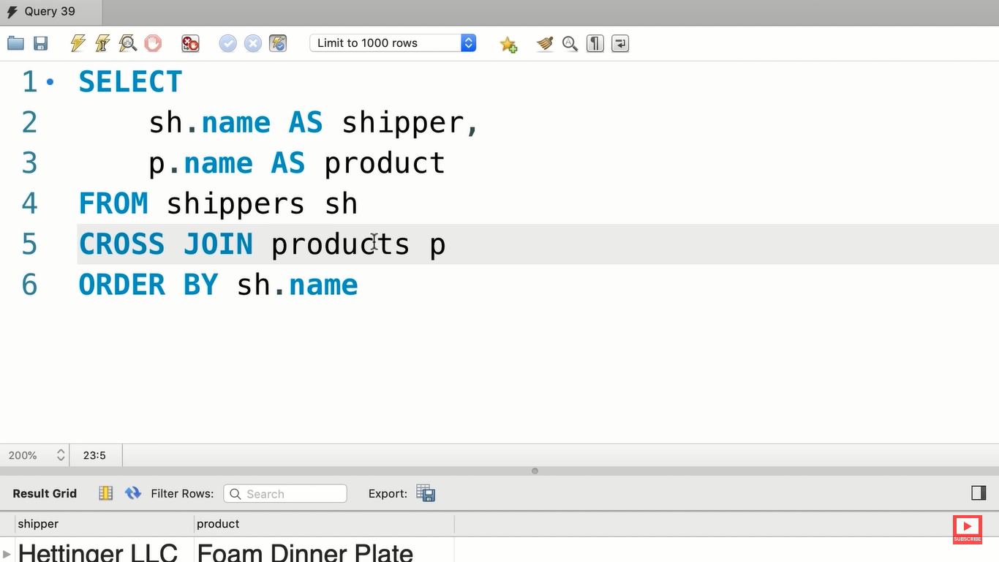

**UNIONS :----**

**To combine rows**

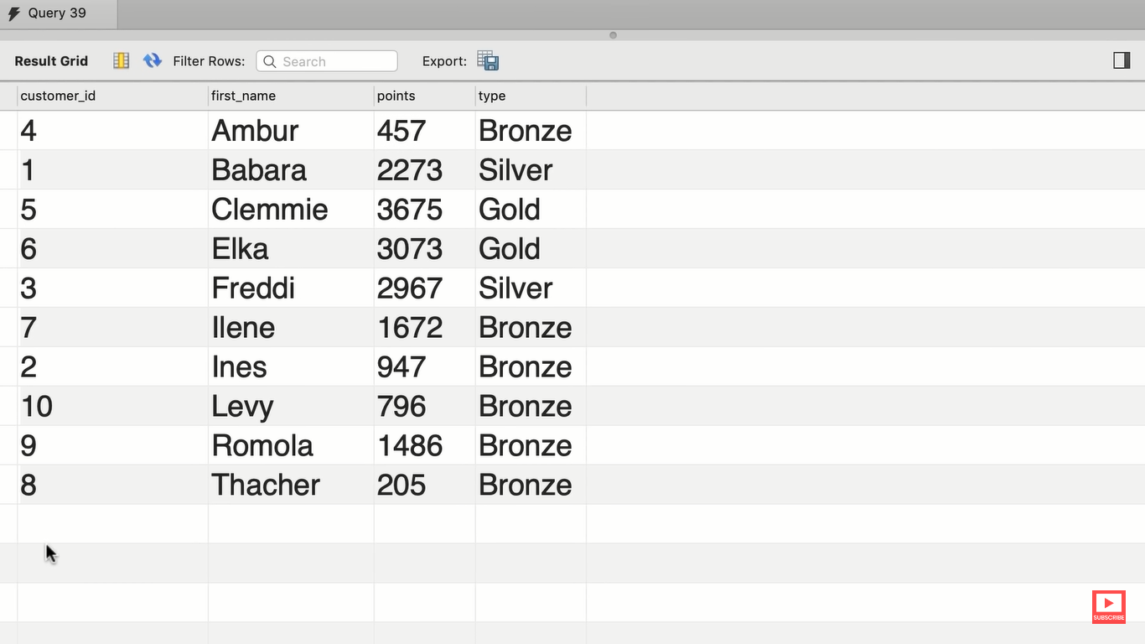

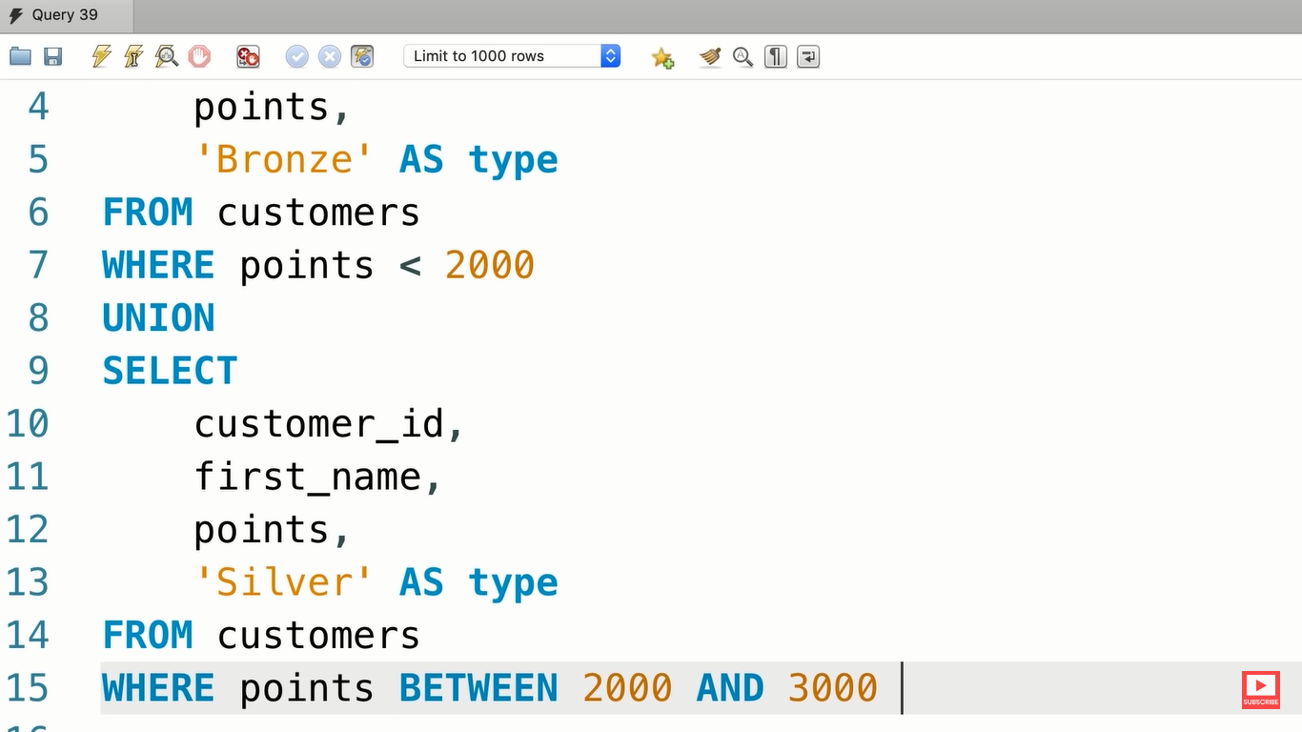

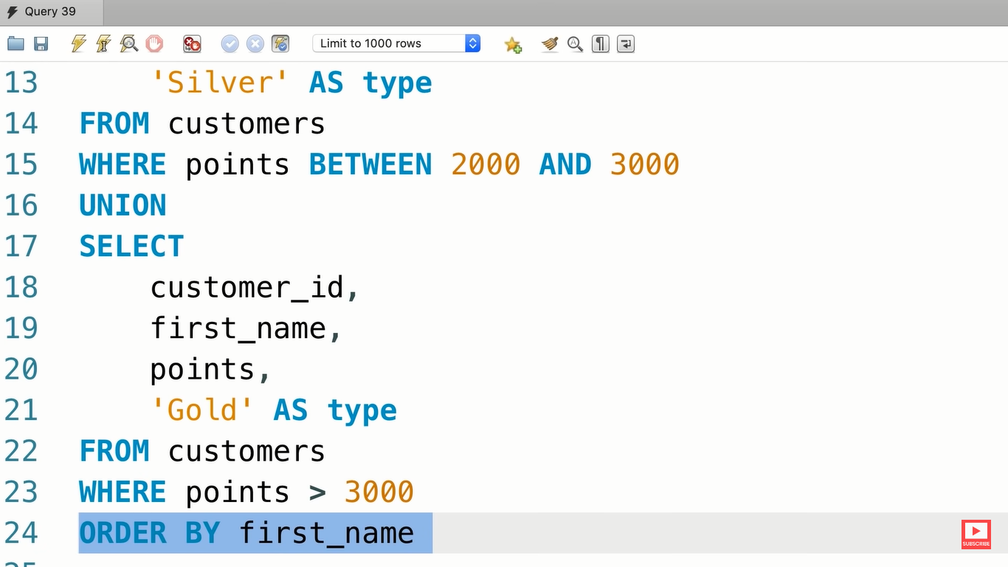

**COLUMN ATTRIBUTES :---**

**INSERTING A SINGLE ROW :---**

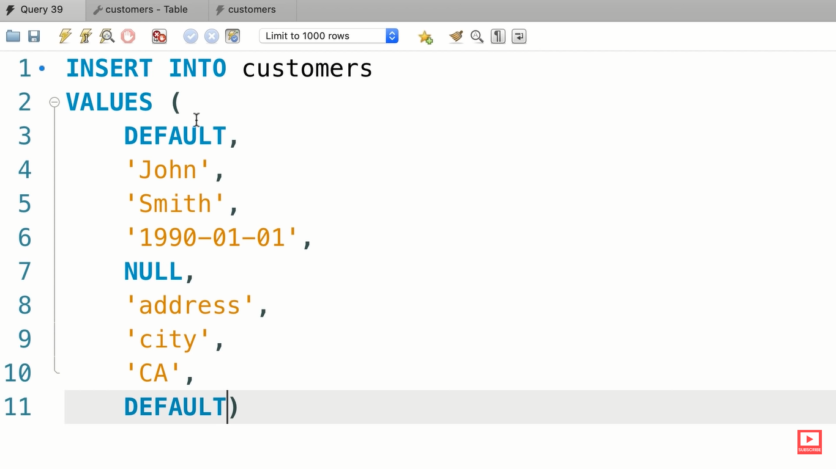

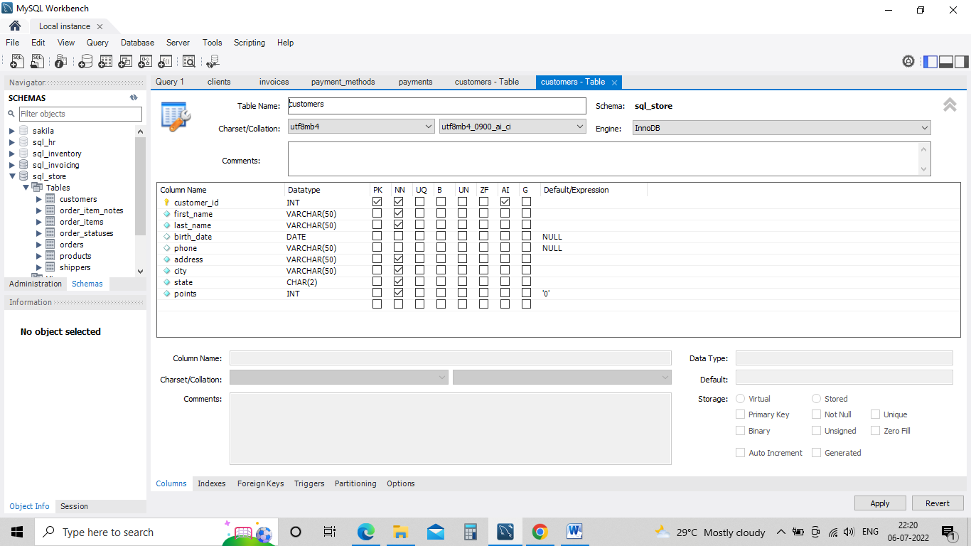

**OR we can write in other ways also**

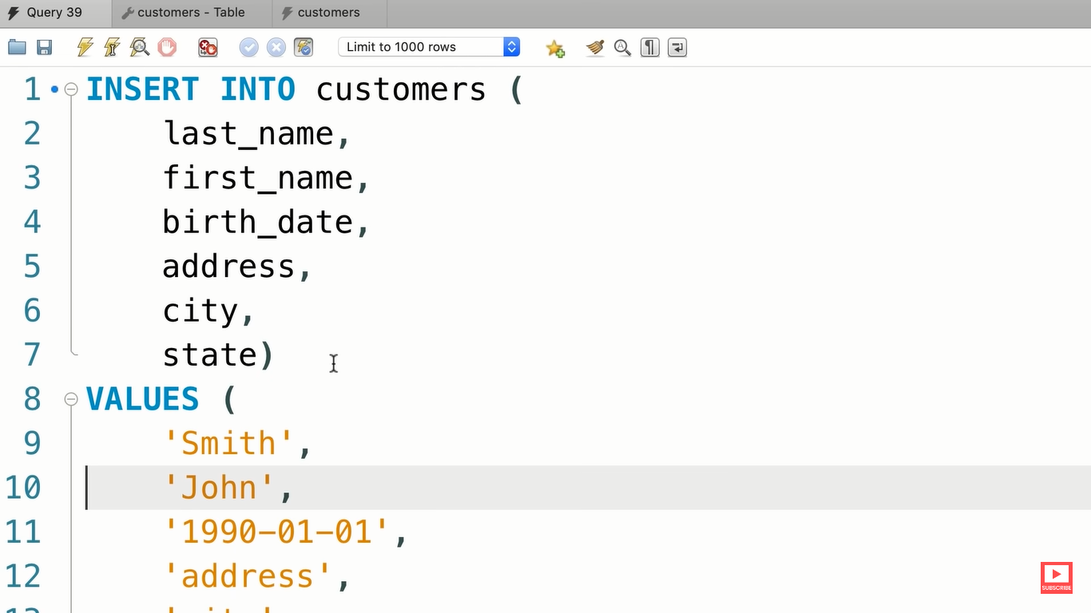

**INSERTING MULTIPLE ROWS :----**

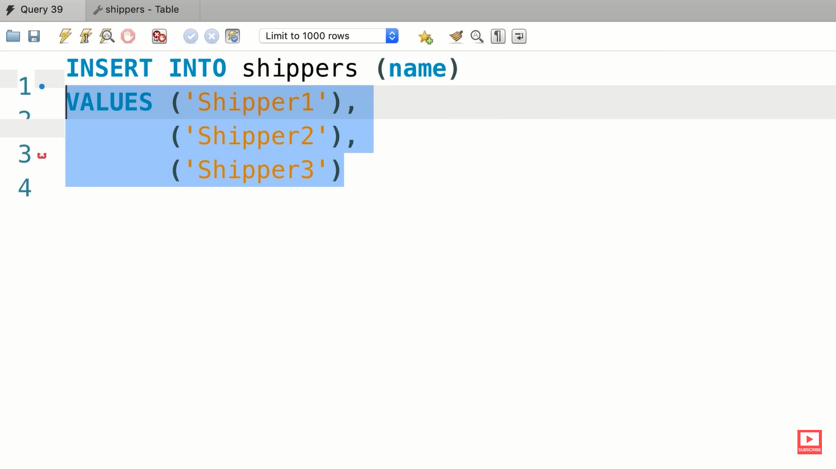

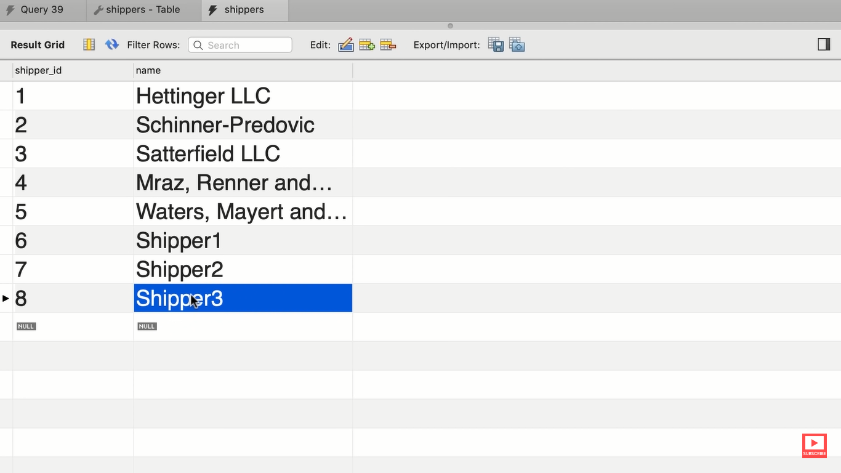

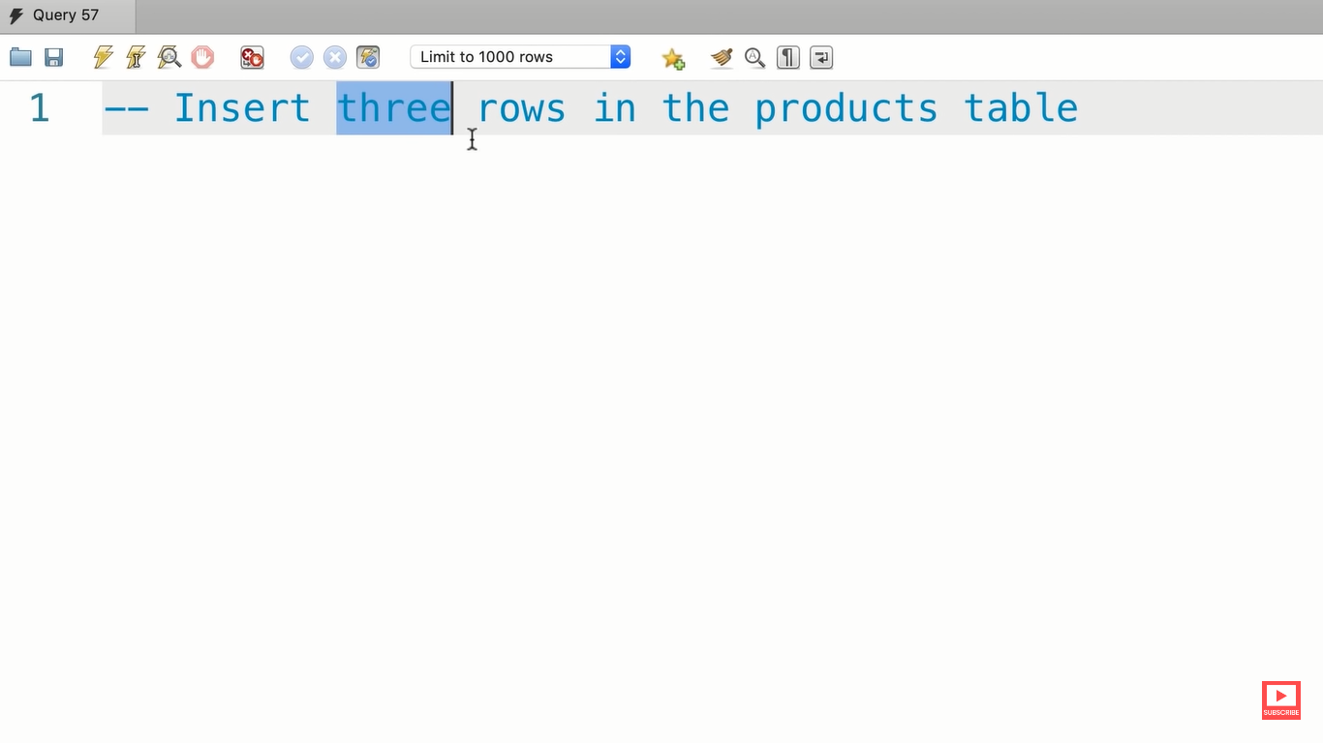

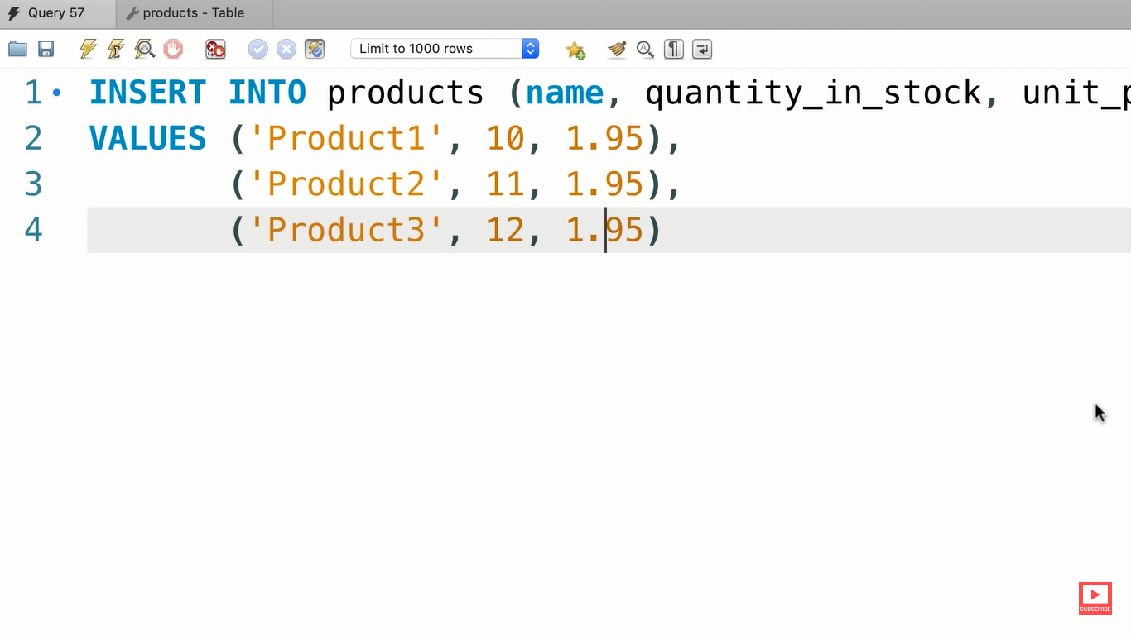

**INSERTING HIERARCHICAL ROWS :---**

Inserting data in multiple tables

**CREATING A COPY OF TABLE :---**

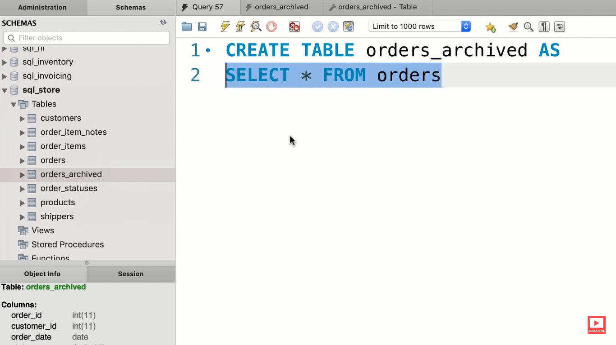

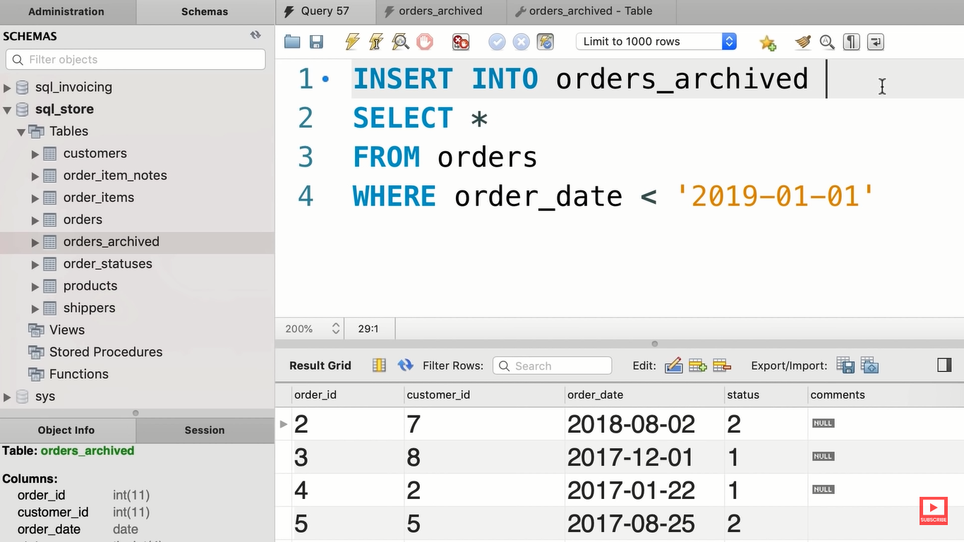

**EXERCISE :---**

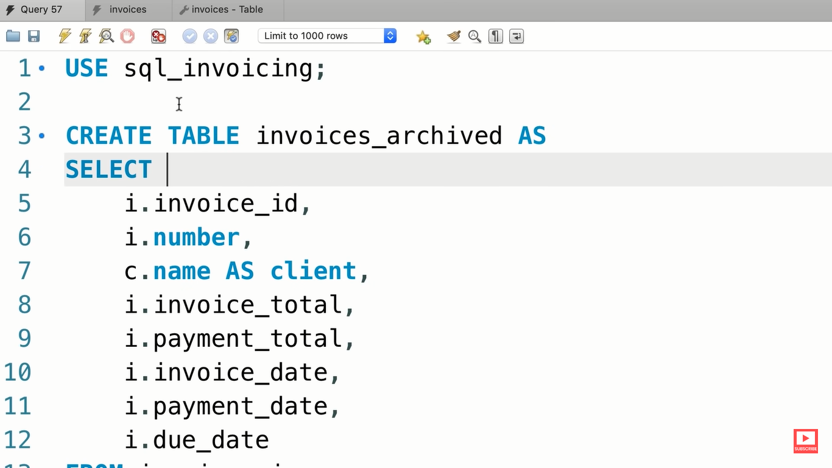

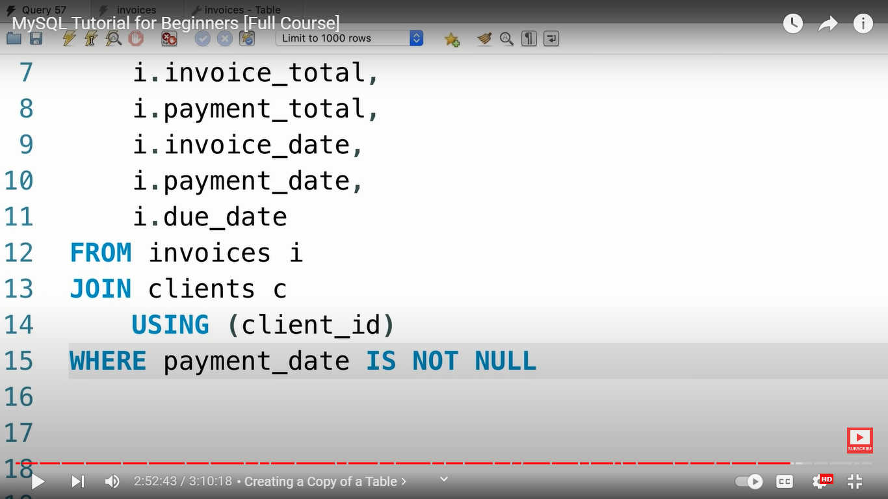

**UPDATING SINGLE ROW :---**

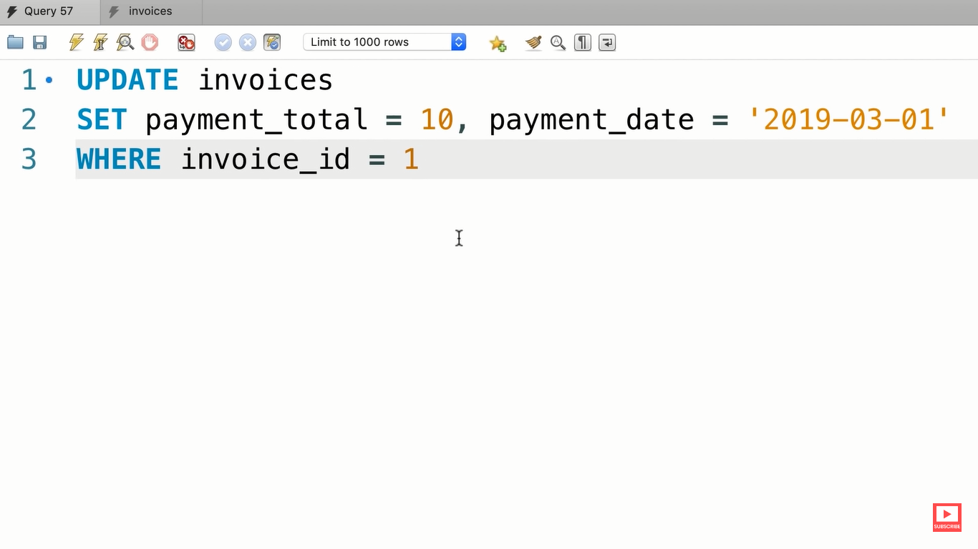

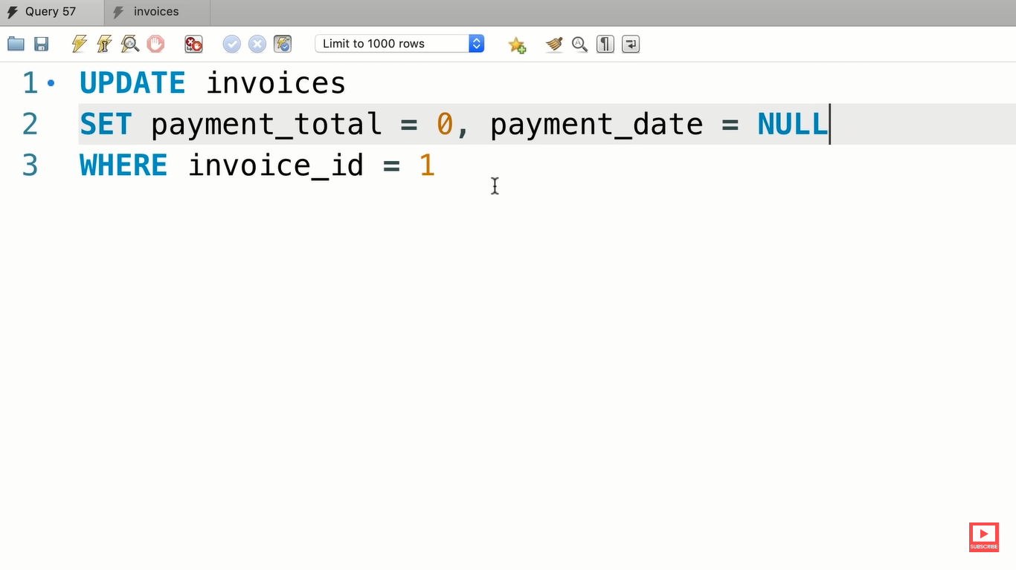

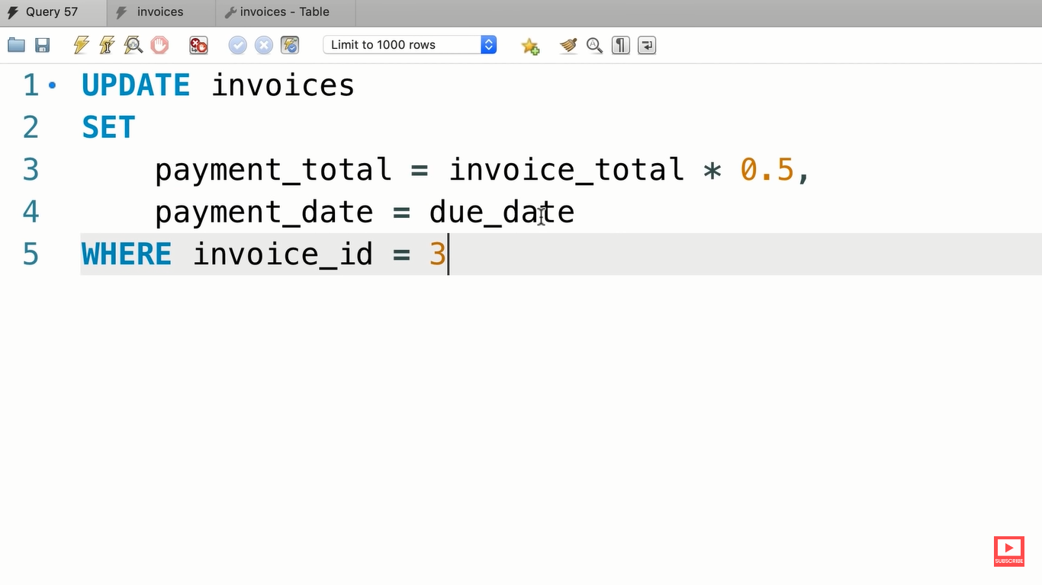

**UPDATING MULTIPLE ROWS :---**

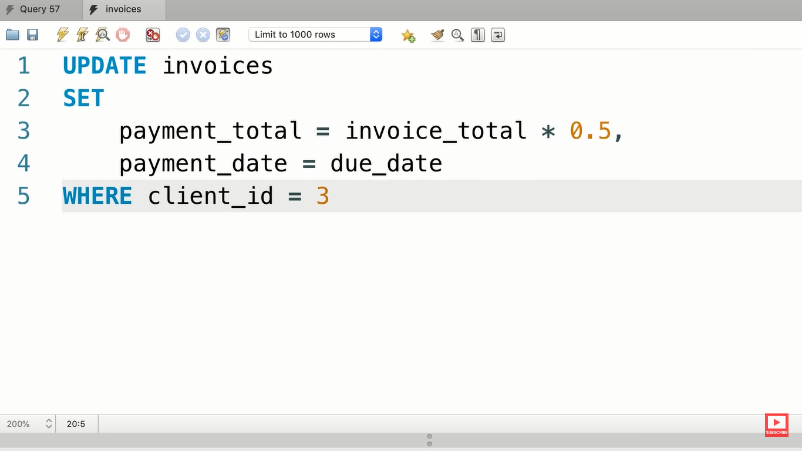

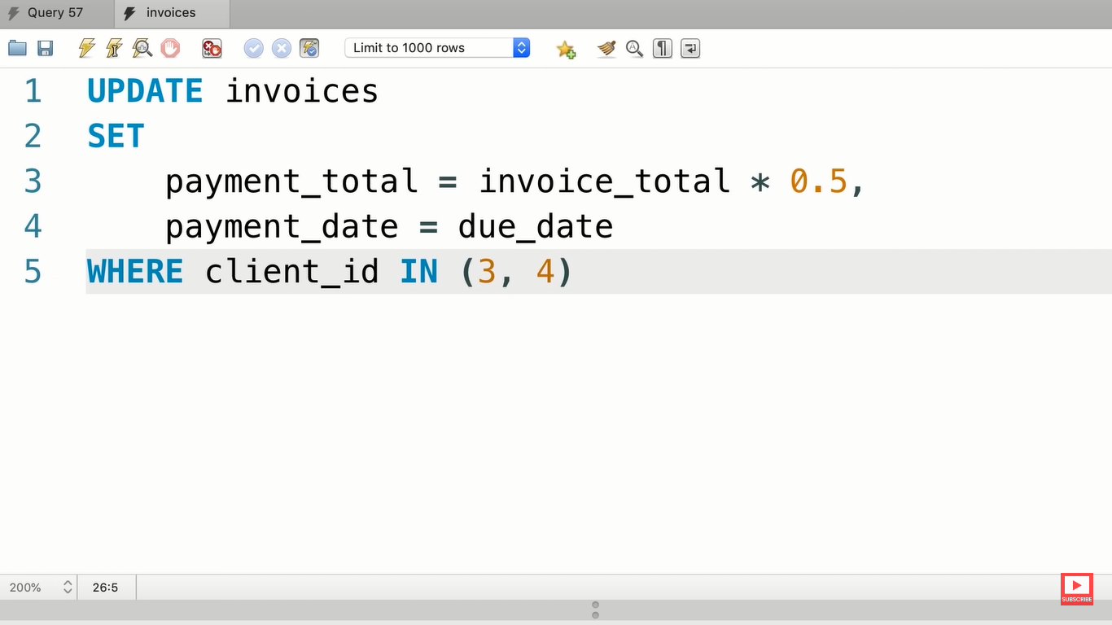

**EXERCISE :--**

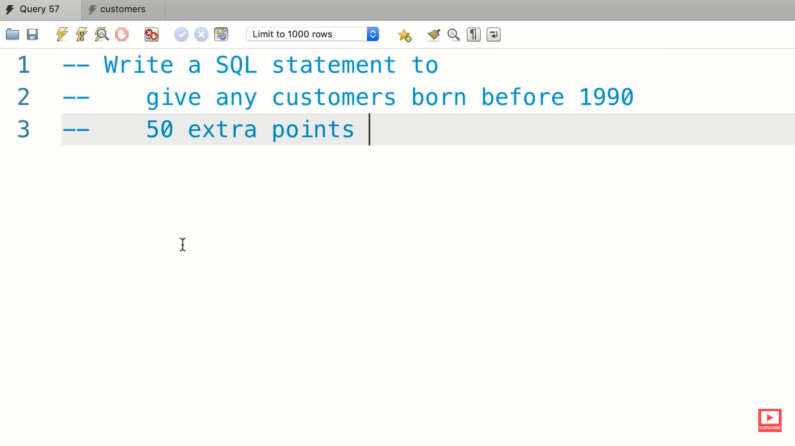

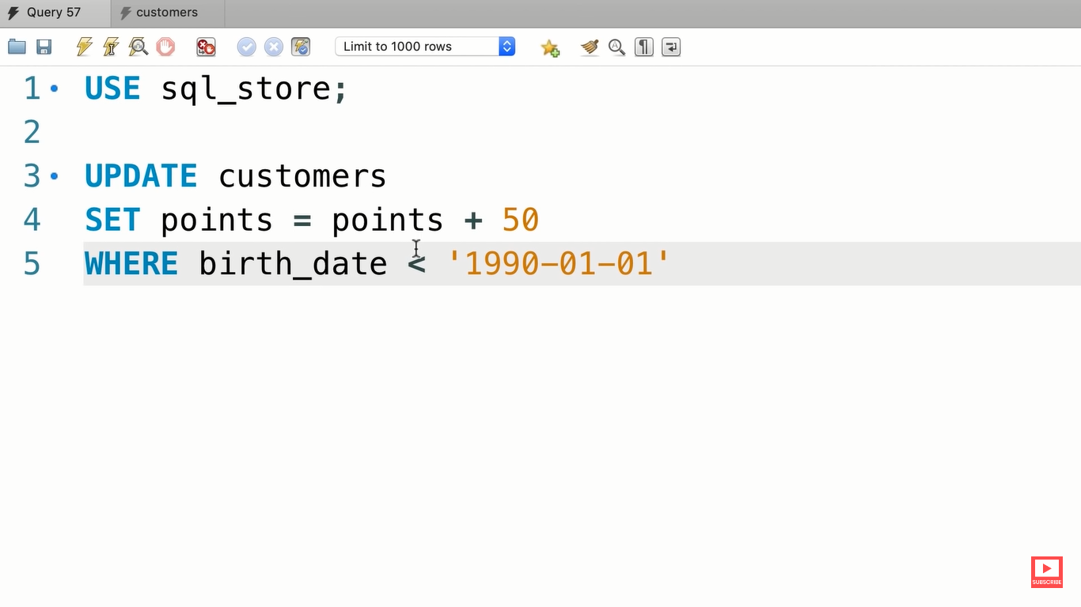

**USING SUB QUERIES IN UPDATES :---**

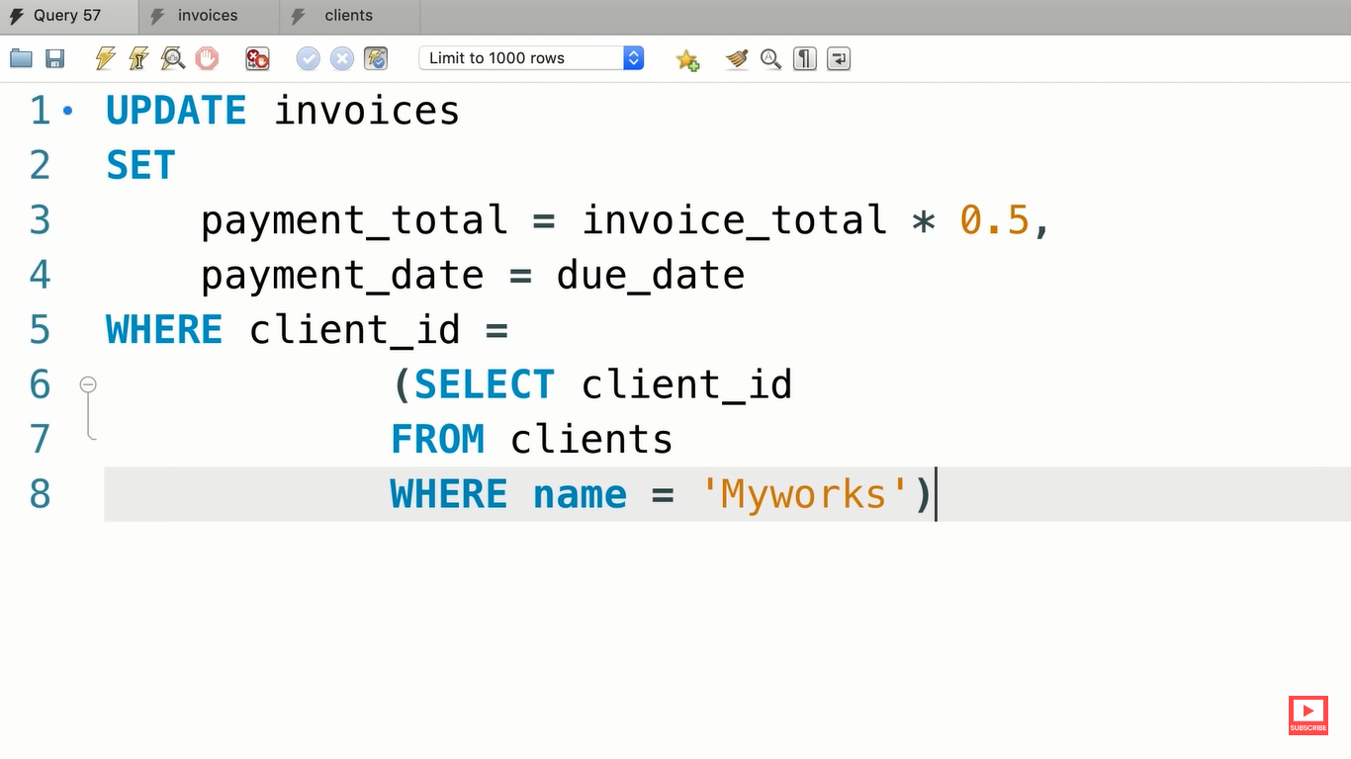

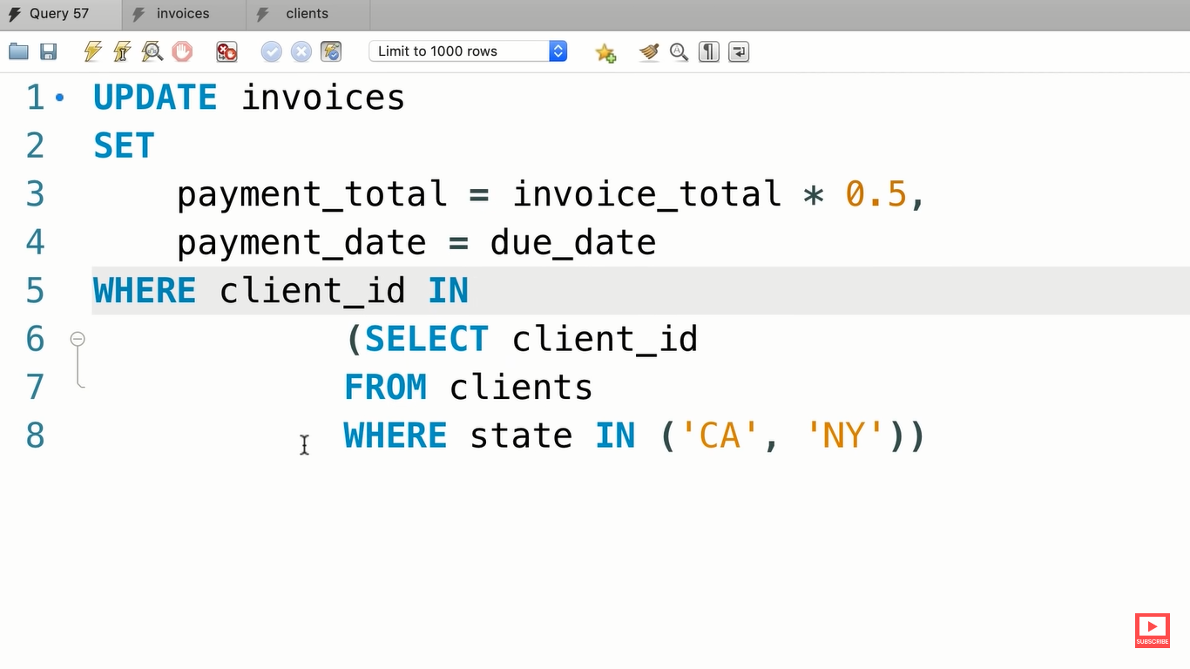

**EXERCISE :---**

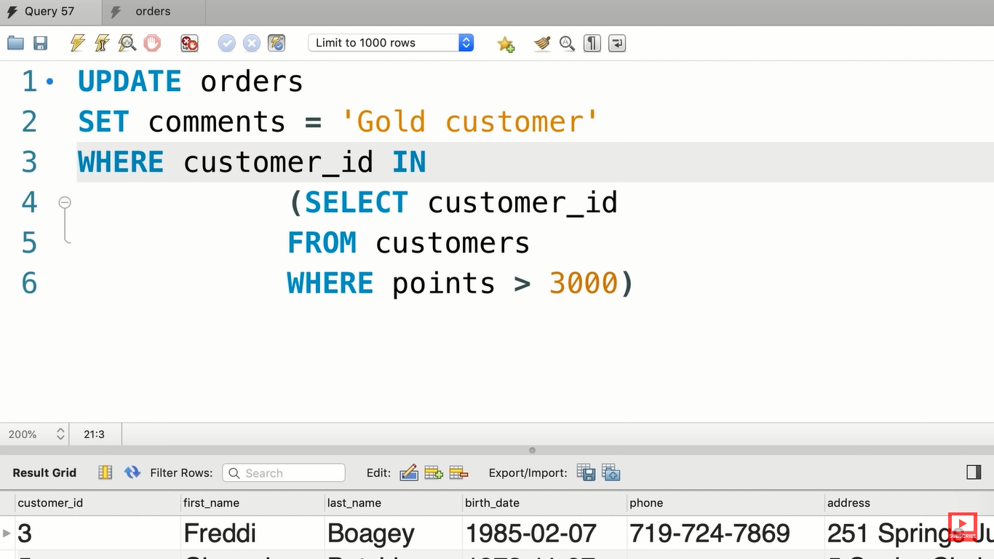

**DELETING ROWS :---**

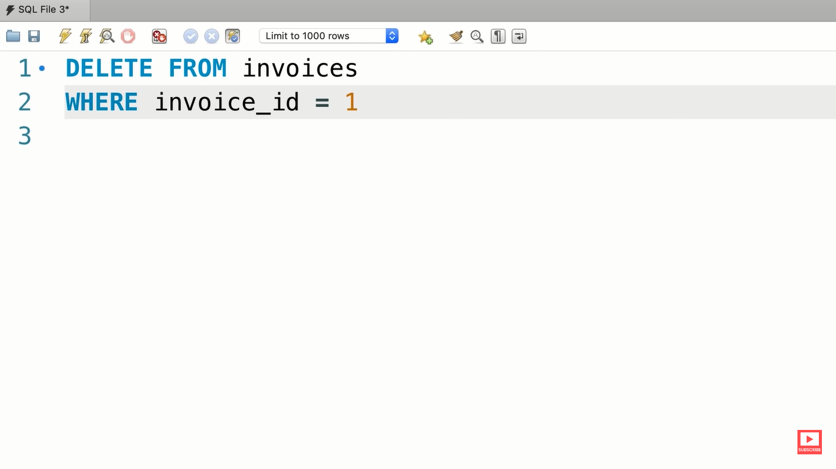

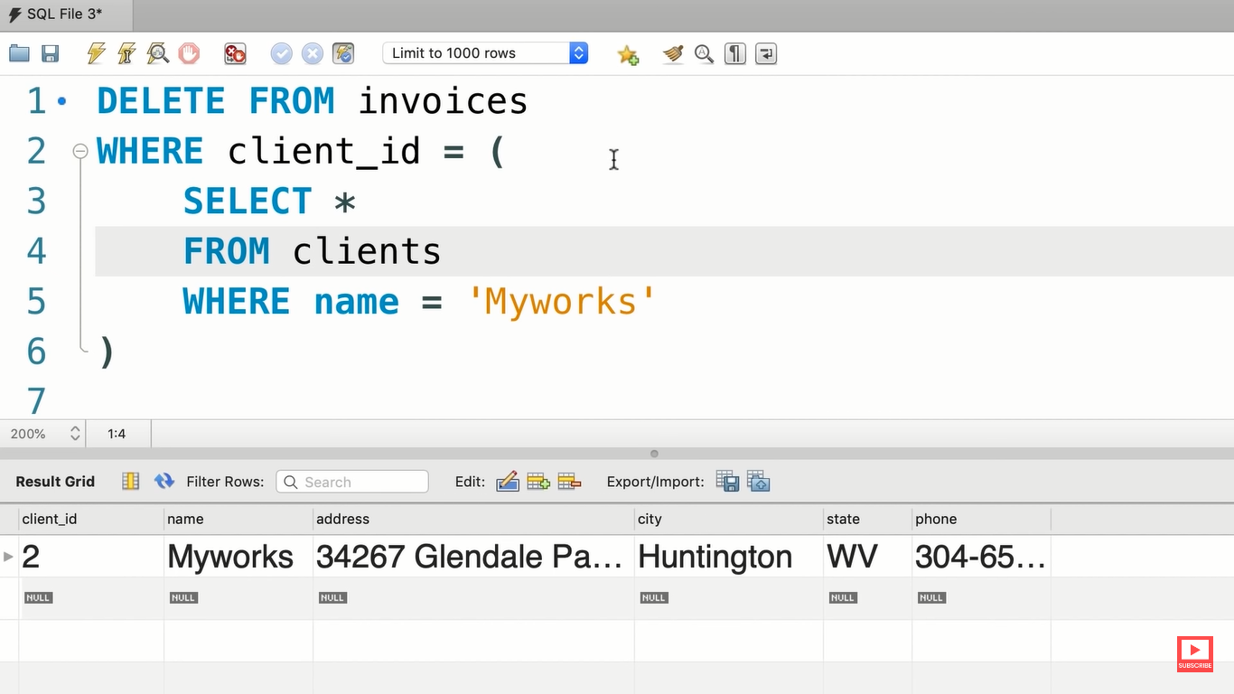

**RESTORING THE DATABASES :---**